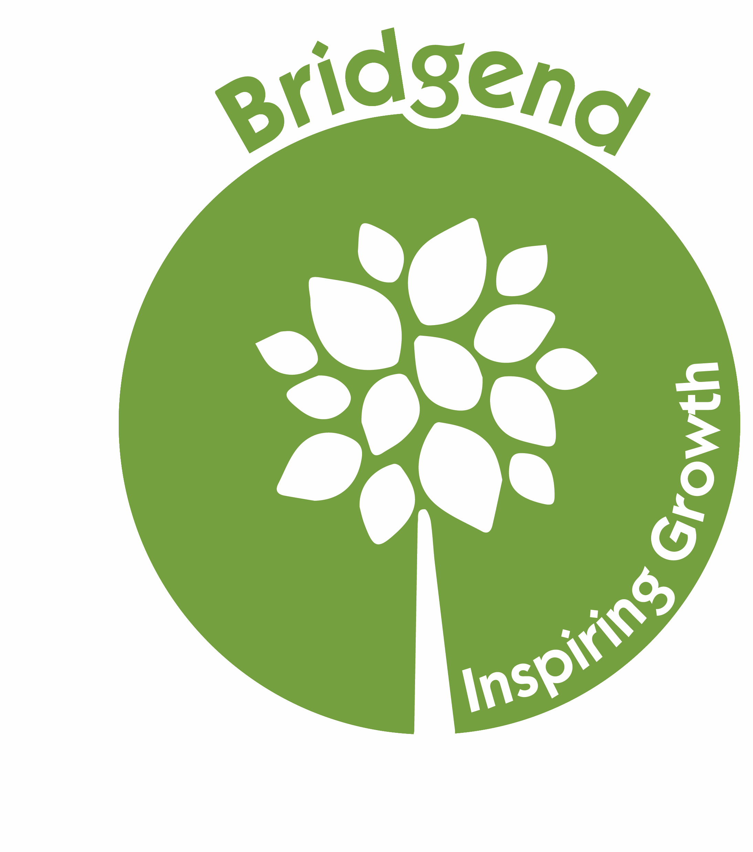
BIG Acorn Fund Reporting Form

Thank you for running an activity using the Acorn Fund.
We would be grateful for your feedback on how the activity went. Please complete this form on a computer or by hand. You
may wish to get your participants to help or feed in their views.

- How many people attended?

- Total number of attendees:

- Total number of individuals (i.e. some people may have come more than once):

- The postcodes from which these people came (e.g. EH16 x 3 could be three people from EH16 or the same person three times – that does not matter for our purposes):

- Who, in your view were these people?
(You could mention how they found out about the activity, whether they were already familiar with Bridgend Farmhouse, whether they had been referred, whether they came from Bridgend’s area of benefit – see: https://www.bridgendfarmhouse.org.uk/our-area-of-benefit.html )

- What worked well? Were your objectives met?

- What didn’t work so well? What would you do differently in future?

- How do you see your future involvement at Bridgend Farmhouse? Would you like to organize a future activity? If so, what?

- Anything else you would like to add:

